WELCOME TO ASSIGNMENT - 2
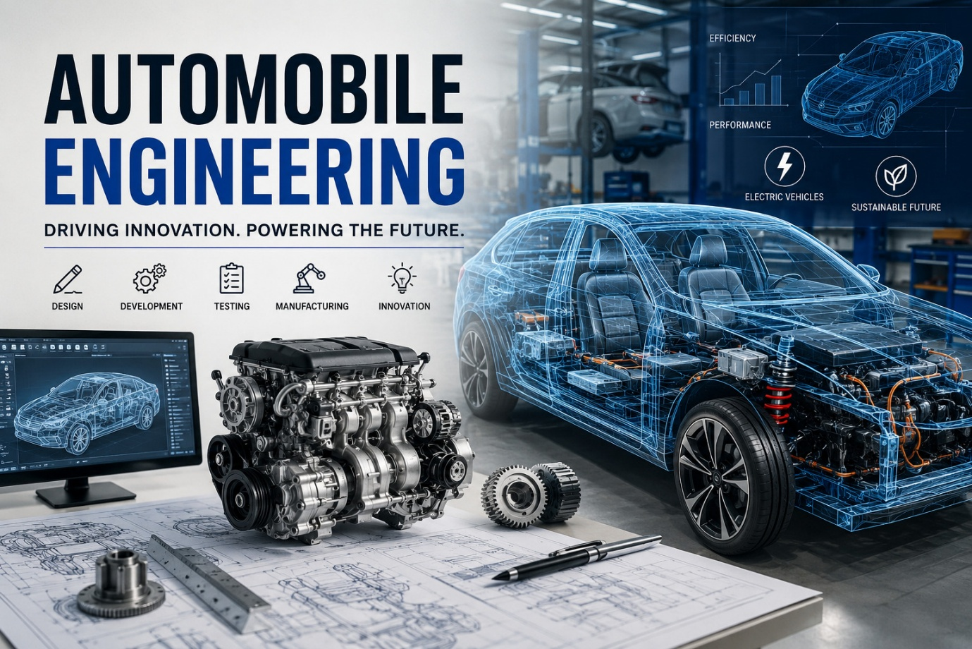
BLOG FEATURED IMAGE: source open AI

“You've probably been wondering what is behind the world of cars, bicycles, and advanced vehicles—automobile engineering turns that curiosity into the technology which shapes our future.”

Topic: Research and SEO- Optimized Blog Creation

Need to demonstrate:
Sl no. | Description
1. | Topic and keyword research
2. | Keyword clustering and intent-based grouping
3. | SEO-optimized content
4. | Technical SEO elements
5. | Image optimization
6. | Content originality

B L O G T O P I C
“Everything You Need to Know About Automobile Engineering”
Submitted By:
Aniket Acharjee
Batch: Digital Marketing with AI (Batch-522)
Website: https://www.bloggercap.info/author/aniketacharjee/

Step 1: Topic Research with Google Trends
Niche: Automobile
Why? : According to Google Trends, Automobile is trending more than Tour & Travels

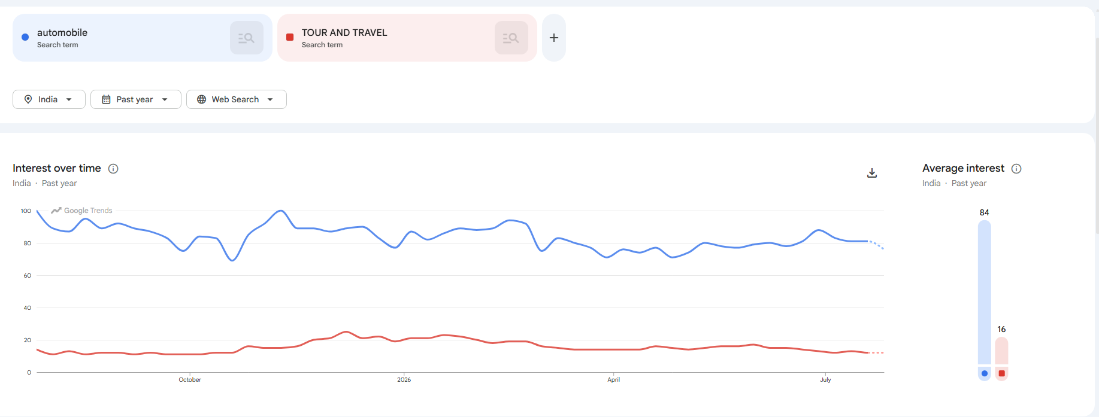

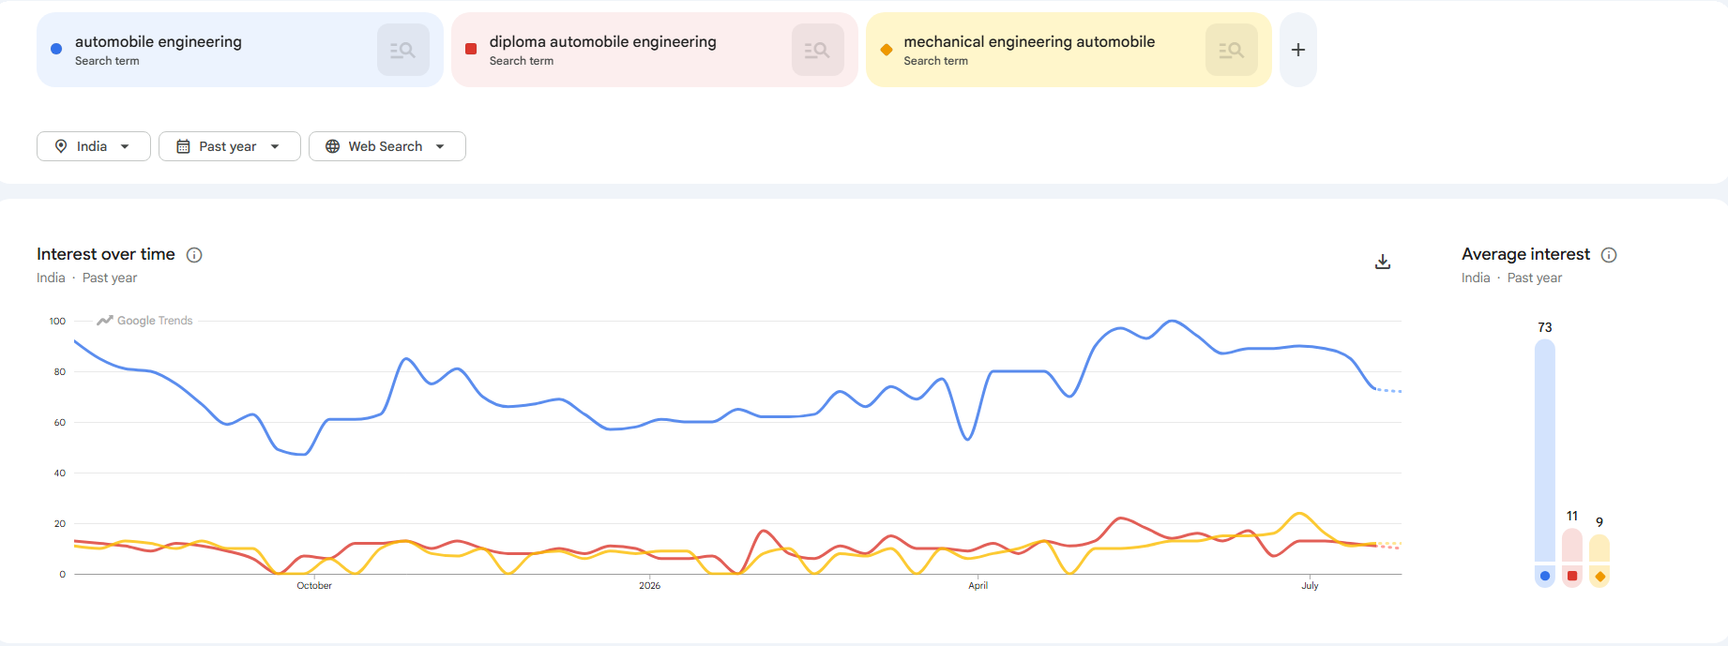
Under automobile, these three topics are trending most:
- Automobile engineering
- Diploma automobile engineering
- Mechanical engineering automobile

Niche | 3 Trending topics | Selected Blog Topic
Automobile | - Automobile engineering  - Diploma automobile engineering  - Mechanical engineering automobile | Automobile engineering

Justification for choosing the topic:
For the past one-year Automobile Engineering has been scoring an average interest of 73. By choosing Automobile Engineering, I can cover a broad range of subjects, including different educational pathways, career opportunities, required skills, and industry trends. This will allow me to provide readers with an easy guide to build a successful career in the automobile industry.
People have also shown interest in courses like:
- Diploma automobile engineering
- Mechanical engineering automobile
I can use these courses for
- keyword relevancies
- search visibility
I have chosen the headline “Everything You Need to Know About Automobile Engineering”, which Ryrob has given a score of 96. It will create a strong curiosity among the users which will help in SEO and rankings.
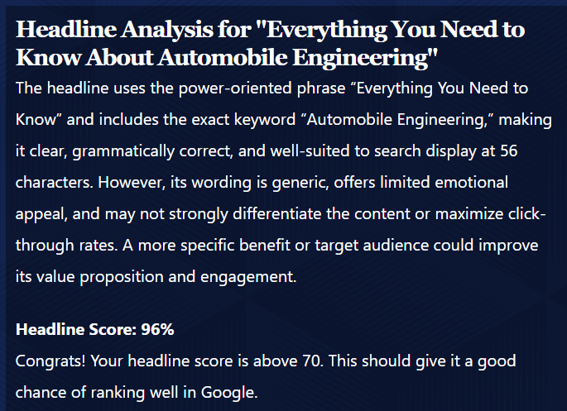
Step-2
Keyword research and clustering with Google Keyword Planner
Keyword | Avg. monthly searches | Three months change | yoy change | competition | Competition  (Index value) | Top page value (low Range) | Top page value (high Range) | Keyword type | Search Intent | Cluster name
automobile engineering | 10K – 100K | 0 | 0 | Low | 4 | ₹25.33 | 85.23 | Focus keyword | Informational | Automobile Engineering Overview
Diploma automobile engineering | 1K – 10K | 0 | 0 | Low | 5 | ₹24.06 | ₹99.88 | Supporting keywords | Informational | Diploma in Automobile Engineering
Mechanical engineering automobile | 1K – 10K | 0 | 0 | Low | 4 | ₹25.54 | ₹92.62 | Supporting keywords | Informational | Mechanical Engineering & Automobile Industry
automotive engineering courses | 1K – 10K | 0 | 0 | Low | 12 | ₹21.81 | ₹81.38 | Supporting keywords | Investigational | Automotive Engineering Education

Step-3
SEO optimized blog
<H1>Exclusive: Everything You Need to Know About Automobile Engineering <H1>
<P> Choosing the right career can help you shape your future. Specifically, if you have a passion for vehicles and engines, automobile engineering could be the perfect field for you. This profession will help you design internal combustion engines or electric vehicles for future transport. Global automobile industry is constantly growing so this remains a promising career. Mechanical automobile engineering, diploma automobile engineering are the few professional degrees that will guide you to get the success in this field.
In fact, this is the field only who are passionate about cars and engines. Engine technologies are evolving from hydrogen cars to electric vehicles to flex fuel engines, so industry is in constant demand for knowledgeable engineers. In addition, thousands of EV manufacturers are entering the industry creating huge job opportunities. For instance, you can start engineering after completing class 10 as diploma engineer. Afterward you can start working or continue studying higher course. In this guide, you will learn about available educational pathways and the scope of this profession. </P>


car manufacturing plant 1

<H2> What is Automobile Engineering? <H2>
<P> It is a branch of engineering that focuses on the design and development of IC engine cars, buses, bikes and electric vehicles. Moreover the industry is constantly evolving with automatic cars and hybrid-powered vehicles, as a result , there is a constant demand of talented and skilled engineers. Specifically, automobile engineers work on engines, transmissions, suspensions, braking and fluid management. </P>
<H3> Automobile Engineering overview <H3>
<P> An automobile engineering overview helps students understand the scope of this profession. In particular this field has concepts from mechanical, electrical, and computer science to build safer and more efficient vehicles. Some of the important areas are:
- Vehicle testing and control
- Engine technology
- Electric and hybrid vehicles </P>

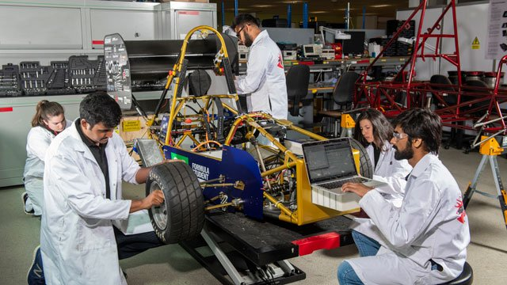
Automobile engineering students 1
<H2> Diploma in automobile engineering <H2>
<P> For instance, students who want to join automobile engineering early can choose diploma automobile engineering. Specifically, it is a three-year course with theoretical and practical hands-on training. Furthermore, it typically starts after class 10. Consequently, it can make you professional ready at a very early age. In addition, it serves as a base for higher studies. Overall, the curriculum generally covers:

- Automobile engines
- Vehicle maintenance
- Automotive electrical systems
- Workshop technology
- Vehicle inspection and servicing
Ultimately, after completing the diploma, students can start working as technician, service engineer, production supervisor. </P>

<H2> Mechanical Engineering Automobile <H2>
<P> Alternatively, mechanical engineering is the base of automobile design and manufacturing. Therefore, students searching for “mechanical engineering automobile” are trying to find the connection between mechanical and automobile engineering. In fact, mechanical engineers help to build a innovative reliable cars with their expertise. </P>
<H3> Mechanical engineer contributes to: <H3>
<P>
- Engine development
- Transmission systems
- Suspension and breaking
- Thermal engineering
- Product testing
Because of this many automotive industries recruits mechanical engineers. Consequently, these engineers can build a successful career in automobile industry. Moreover, with mechanical engineering background you will have options to work for different industries other than automobile sector. You can get jobs in machinery factories, manufacturing plants. </P>

<H2> Automotive Engineering Education <H2>
<P> To begin with, Automotive engineering education prepares students for real-world challenges, specifically with classroom studies and hands-on workshop programme.
Subjects covered are:
- Engineering mechanics
- Thermodynamics
- Automotive engines


car concept drawing 1
- Machine design
- Vehicle
- Manufacturing Technology
Ultimately these gives students a strong foundation. Consequently, their knowledge which will prepare them to build a strong career.</P>

<H2> Automotive engineering courses <H2>
<P> Currently, there are different automotive courses available for students. For instance, common courses are:
- Diploma programs
- Bachelor's degree (B. Tech /B.E.)
- Master's degree (M. Tech)
- Certificate courses
- Short-term industry certification programs
In addition to, there are also many online specialized courses for electric vehicles, automotive software, and manufacturing technologies, helping students to stay updated.</P>

<H2> Career Opportunities: <H2>
<P> First and foremost, automobile sector has career opportunities in both govt. and private sectors. Opportunities are there across the world. Specifically, A graduate can work as:
- Automobile Engineer
- Design Engineer
- Production Engineer
- Service Engineer
- Quality Control Engineer
- Research & Development Engineer
- Vehicle Testing Engineer
Furthermore, employers are automobile manufacturers, component suppliers, electric vehicle startups, etc</P>

<H3> Essential key for success: <H3>
<P> Crucially, Success in the automobile industry requires both technical expertise and problem-solving ability.
In particular important skills include:
- Analytical thinking
- Mechanical aptitude
- Computer-aided design (CAD)
- Communication skills
- Team collaboration
- Attention to detail
- Creativity
- Continuous learning
Ultimately, as technology is continuously evolving, engineers who adapt well will enjoy greater career growth.</P>
<H2> Future Scope in automotive industry: <H2>
<P> Looking ahead, future of automobile industry looks promising as both govt. and pvt sector organizations are investing heavily on electric vehicles, intelligent cars, and environmental friendly vehicles. Consequently, there are job opportunities across the world. Furthermore, automobile and vehicles will only evolve year on year and can never go out of demand. Therefore, with dedication you can expect high level growth in future.
Emerging areas are:
- Electric vehicles (EVs) (internal link)
- Hydrogen fuel-cell vehicles (external link)
- Artificial Intelligence in mobility
- Autonomous driving
- Smart manufacturing </P>

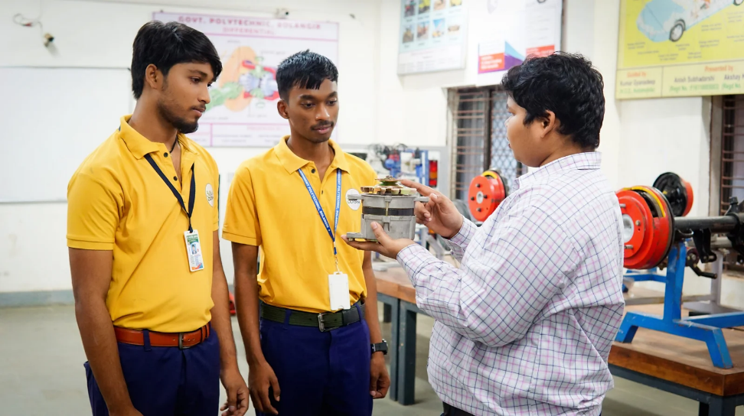
automobile engineering class demonstrati 1

<H2> Conclusion: <H2>
<P> If you enjoy understanding how vehicles work and want to make a career in it, automobile engineering gives you a career path to become automobile engineer. Ultimately, whether you choose diploma or engineering with dedication you can reach heights.
Select colleges and compare their infrastructure, placement support and industry exposure. With the right education and your dedication, you can build a successful career in automotive world.
However, For more information about automobile and car manufacturing courses you
click: car manufacturing courses </P>

Word count – 877
Tone analysis – Tone is highly encouraging and supportive. It treats the reader like an ambitious student, highlighting opportunities and validating their passion for cars. It maintains a professional yet accessible vibe throughout.
Blog structure –
H1 – “Everything You Need to Know About Automobile Engineering”
Headlines with focus key word (Automobile Engineering)

Meta Title & Meta Description

Used tools for meta title analyser:
( https://www.traffic-masters.net/tools/meta-title-checker/)
Meta Title has scored an excellent score of 85.
Meta Title: Automobile engineering: career, courses & future scope
Meta Description: Discover automobile engineering, mechanical engineering automobile and automotive engineering courses and the future scope in this industry

SERP PREVIEW:
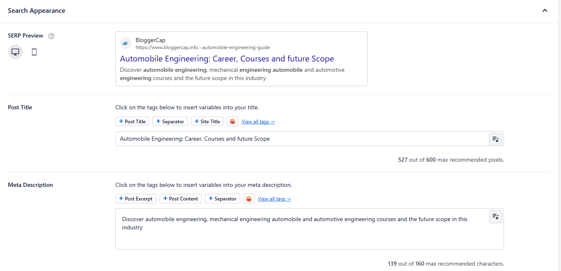

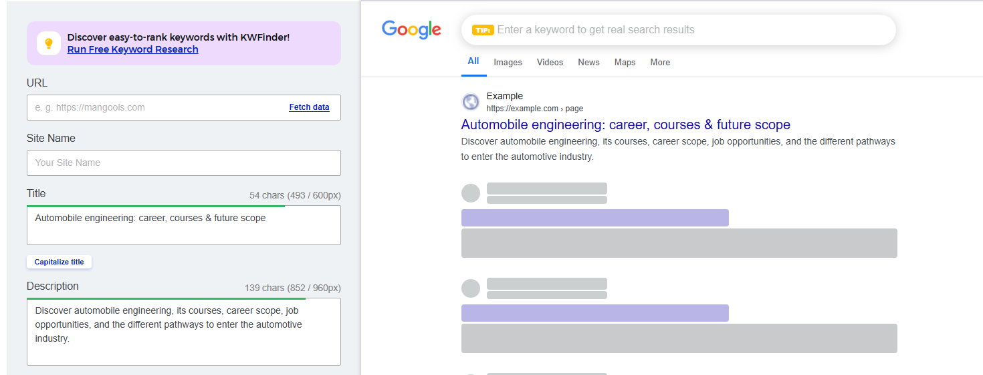

Meta Title and Meta Description are optimised with keywords and within character and pixel limits.
Used tools:
Mangools - https://www.mangools.com/free-seo-tools/serp-simulator (for meta title and description)
Ryrob – https://www.ryrob.com/headline-analyzer/ (for headline analysis)

URL SLUG - /automobile-engineering-guide/
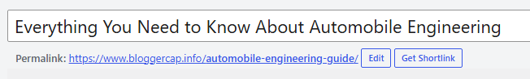
URL - https://www.bloggercap.info/automobile-engineering-guide/
Keyword Placements:
Focus and additional keywords report
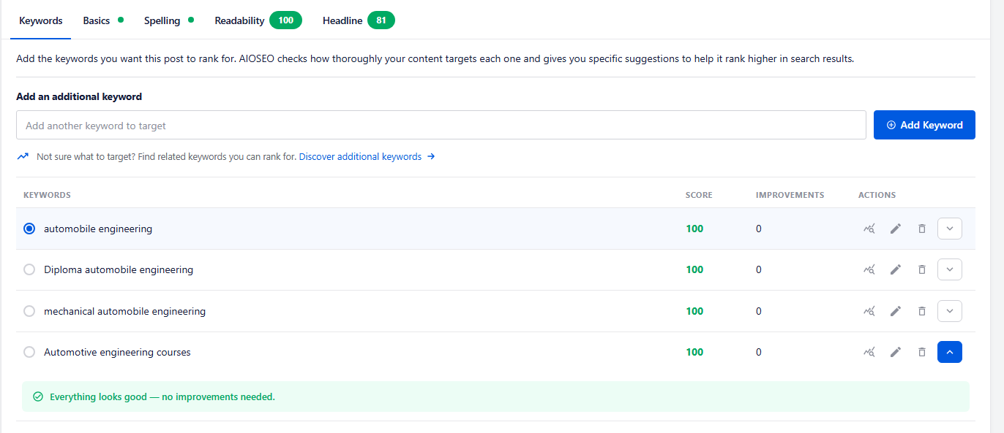
All the keywords scored 100 1
Internal Links:
- https://www.bloggercap.info/electric-cars-and-price-in-india/
- https://www.bloggercap.info/learn-car-manufacturing/
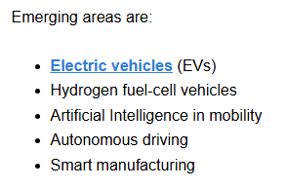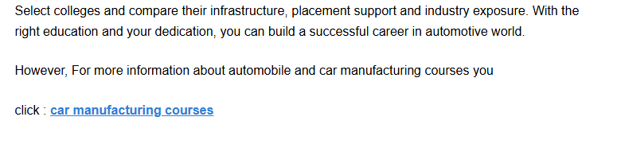
External Links:
- https://pngtree.com/freebackground/modern-car-assembly-line-automotive-factory-stock-photo_15756406.html
- https://www.surrey.ac.uk/postgraduate/automotive-engineering-phd
- https://www.vecteezy.com/free-photos/automotive-engineering
- https://gpblgr.ac.in/automobile-engineering/
- https://www.caranddriver.com/features/a41103863/hydrogen-cars-fcev/

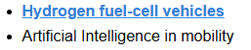
* All the images are external linked except featured image which is from OpenAI, and anchor text “hydrogen fuel-cell vehicles”
Step-4
Image optimization:
Blog Title | Image URL | Filename | Alt Text
“Everything  You Need to Know About Automobile Engineering” | https://pngtree.com/freebackground/modern-car-assembly-line-automotive-factory-stock-photo_15756406.html | Car manufacturing plant | car-manufacturing-plant-assembly-line
“Everything  You Need to Know About Automobile Engineering” | https://www.surrey.ac.uk/postgraduate/automotive-engineering-phd | students-group-automotive-engineering | students-group-automotive-engineering
“Everything  You Need to Know About Automobile Engineering” | https://www.vecteezy.com/free-photos/automotive-engineering | automotive-engineering-concept-drawing | automotive-engineering-concept
“Everything  You Need to Know About Automobile Engineering” | https://gpblgr.ac.in/automobile-engineering/ | automobile engineering students class | mechanical-automobile-engineering-students-class-demonstration

Step-5:
Technical SEO Elements
Schema Markup (JSON-LD BlogPosting)
<script type="application/ld+json">
{
"@context": "https://schema.org",
"@type": "BlogPosting",
"mainEntityOfPage": {
"@type": "WebPage",
"@id": "https://www.bloggercap.info/automobile-engineering-guide/"
},
"headline": "Everything You Need to Know About Automobile Engineering",
"description": "Discover automobile engineering, mechanical engineering automobile and automotive engineering courses and the future scope in this industry",
"image": [
"https://www.bloggercap.info/wp-content/uploads/2026/07/Automobile-engineering-featured-image.jpg.webp",
"https://www.bloggercap.info/wp-content/uploads/2026/07/Car-manufacturing-plant.jpg.webp",
"https://www.bloggercap.info/wp-content/uploads/2026/07/students-group-automotive-engineering.jpg.webp",
"https://www.bloggercap.info/wp-content/uploads/2026/07/automotive-engineering-concept-768x430.jpeg.webp",
"https://www.bloggercap.info/wp-content/uploads/2026/07/automobile-engineering-students-class-768x432.webp"
],
"author": {
"@type": "Person",
"name": "Aniket Acharjee",
"url": "https://www.bloggercap.info/author/aniketacharjee/"
},
"publisher": {
"@type": "Organization",
"name": "https://www.bloggercap.info/",
"logo": {
"@type": "ImageObject",
"url": "https://www.bloggercap.info/wp-content/uploads/2025/06/croppedbloggercaplogo-e1749568521427.png"
}
},
"datePublished": ""
}
</script>

Rich Test Result:
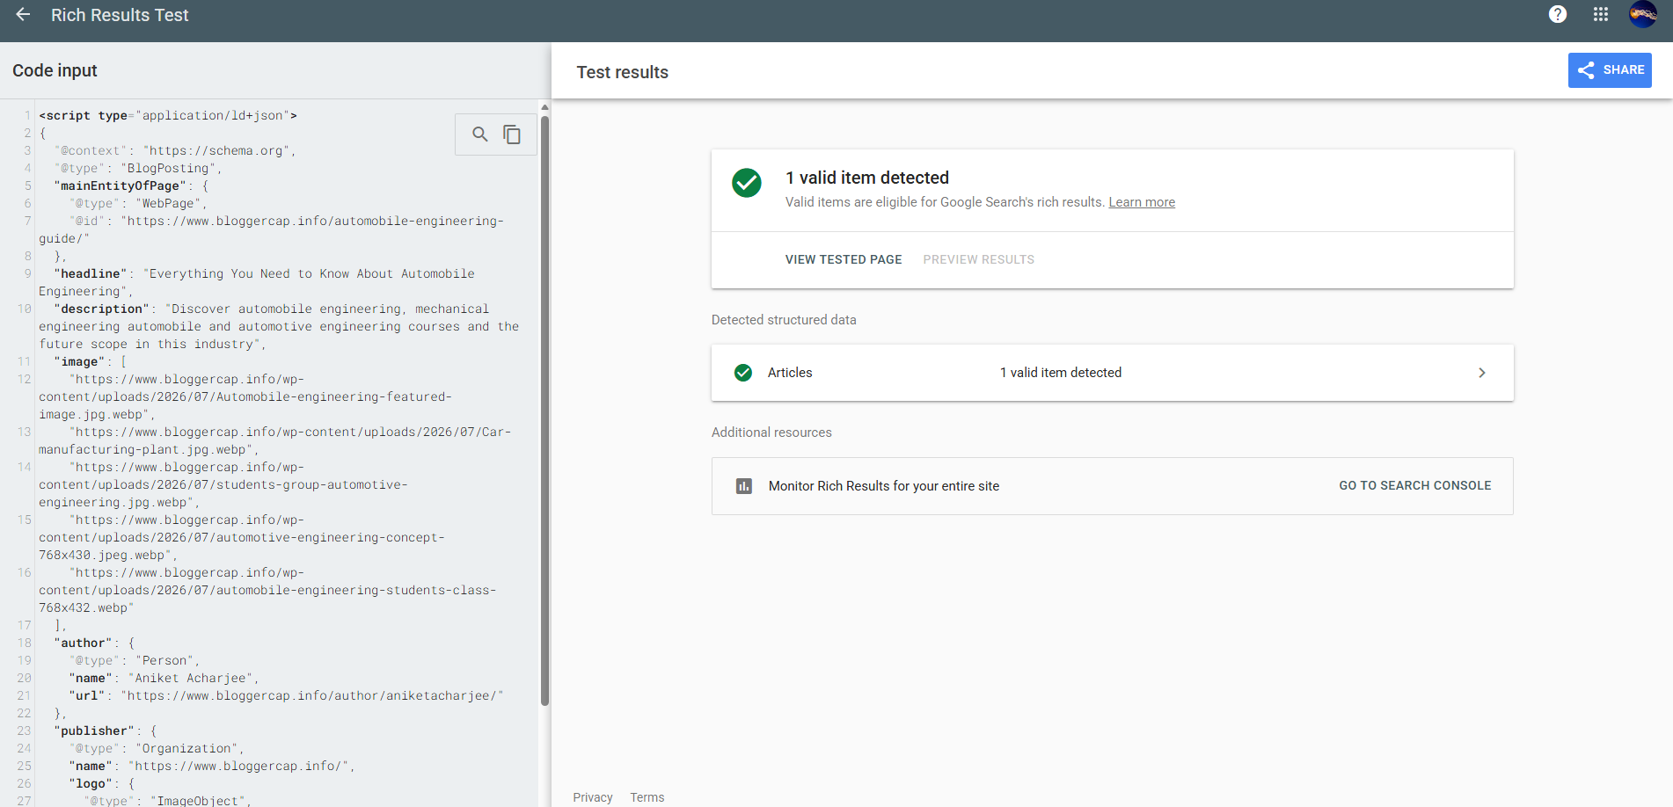
Custom schema applied:

Open Graph (OG) Tags: Social Appearance - Facebook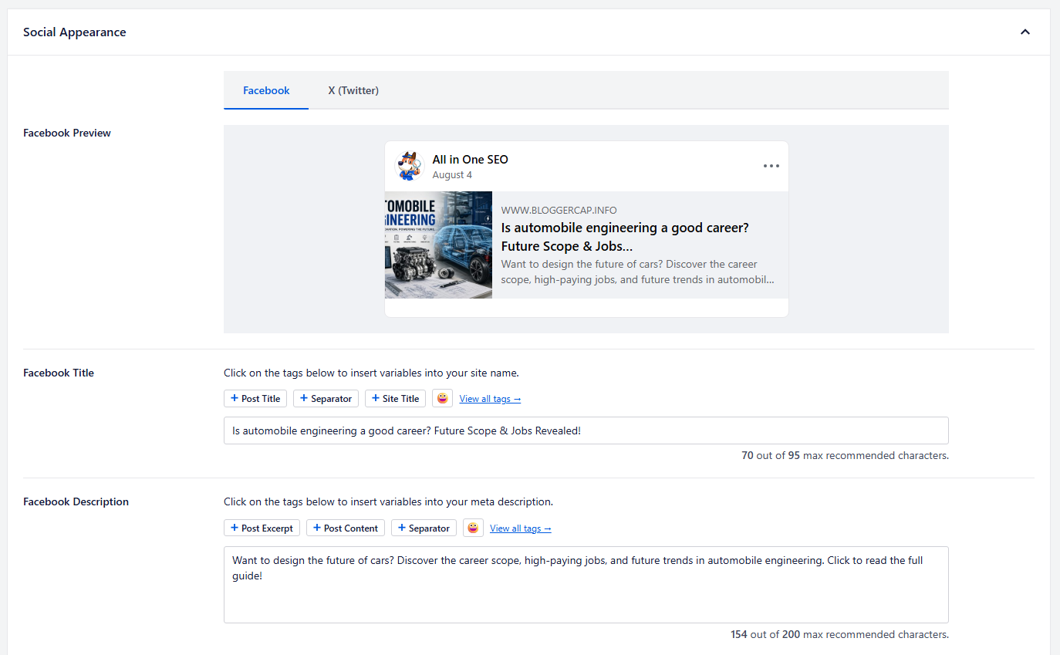
FB title and description have been optimised
Social Appearance – X twitter
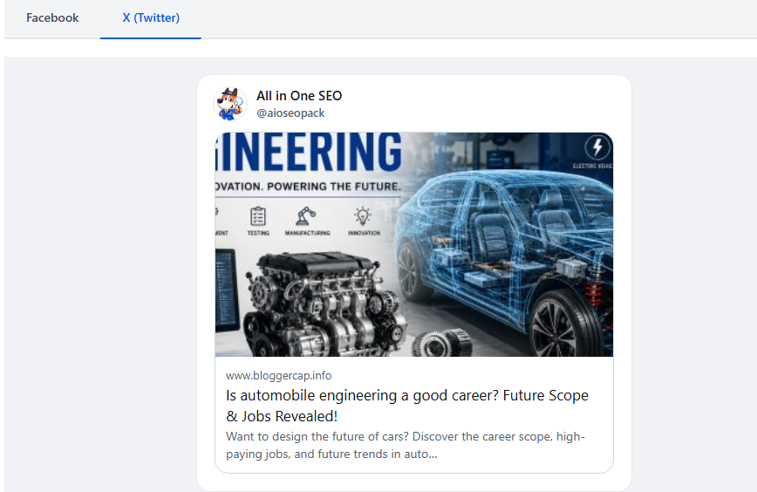

Step-6
Plagiarism and AI content checker:
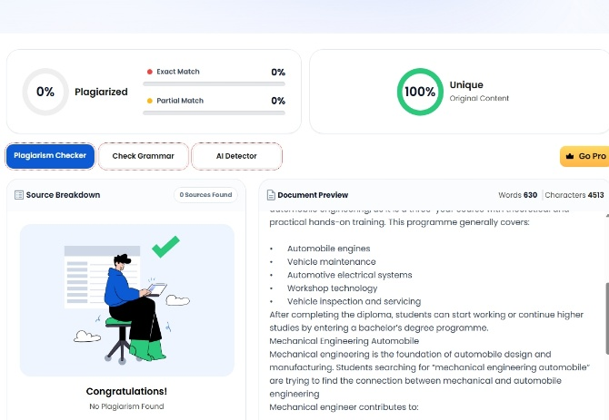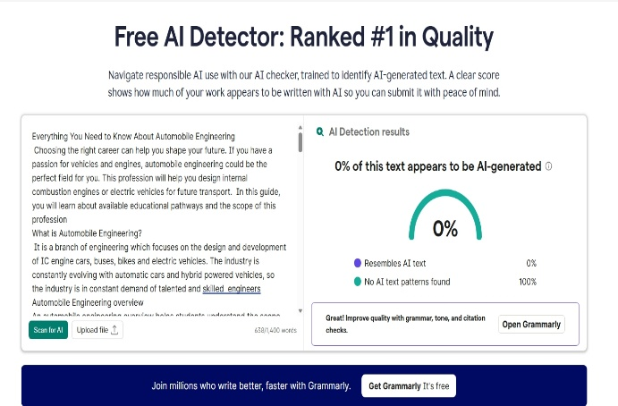

AI detector tool - www.grammarly.com/ai-detector
Plagiarism checker - www.duplichecker.com

Canonical URL and Sitemap and AIOSEO Score:
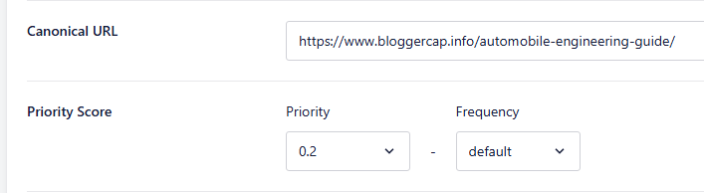

Conclusion
This project successfully demonstrated the complete process of creating a research-based and SEO-optimized blog on “Everything You Need to Know About Automobile Engineering.” The project was completed through a systematic step-by-step approach, beginning with topic research using Google Trends to identify a relevant and trending niche. Automobile Engineering was selected after comparing topics and analysing its search interest and potential.
The next step was keyword research and clustering using Google Keyword Planner. A focus keyword, supporting keywords, search intent, and relevant keyword clusters were identified to create a clear content strategy. The blog was then developed using these keywords naturally, with a structured H1, H2, and H3 heading hierarchy and informative content covering education, courses, career opportunities, required skills, and future scope.
The project also incorporated important technical and on-page SEO elements, including an optimized meta title and meta description, SEO-friendly URL slug, internal and external links, keyword placement, image filenames and alt text, and custom BlogPosting Schema Markup in JSON-LD. Open Graph elements were also optimized for social media appearance.
Finally, plagiarism and AI-content checking tools were included as part of the quality-control process. Overall, the project achieved its intended goal by combining research, keyword strategy, content creation, on-page SEO, technical SEO, image optimization, and content-quality checks into one complete SEO workflow. This demonstrates the practical application of the skills required to create a search-friendly and user-focused blog from research to final optimization.

Thank YOU

